CIS11 Lab 7: Multiply and Divide using LC-3 Programming

In this lab, we will create a program that contains instructions to multiply and divide values. See below procedures for details.

Problem Statement
Given two integers X and Y compute the product XY (multiplication), the quotient X/Y (integer division), and the modulus (X mod Y) (remainder).

Inputs
The integers X and Y are stored at locations 3100 and 3101, respectively.

Outputs
- The product XY, the quotient X/Y, and modulus X (mod Y) are stored at locations 3102, 3103, and 3104, respectively.
- If X, Y inputs are invalid for X/Y and X (mod Y) (see section 5.2.5 on page 5–3) place 0 in both locations 3103 and 3104.

Program

Subroutines
Subroutines in assembly language correspond to functions in C/C++ and other computer languages:
- They form a group of code that is intended to be used multiple times.
- They perform a logical task by operating on parameters passed to them, and at the end they return one or more results.
  - As an example consider the simple subroutine in listing 5.1 which implements the function F_{n} = 2n+3. The integer n is located at 3120, and the result Fn is stored at location 3121.
  - Register R0 is used to pass parameter n to the subroutine, and R1 is used to pass the return value f (n) from the subroutine to the calling program.
- Execution is transferred to the subroutine using the JSR (“jump to subroutine”) instruction. This instruction also saves the return address that is the address of the instruction that follows JSR, in register R7. See figure 5.1 for the steps taken during execution of JSR.
- The subroutine terminates execution via the RET “return from subroutine” instruction. It simply assigns the return value in R7 to the PC.
The program will have two subroutines: MULT for the multiplication and DIV for division and modulus.
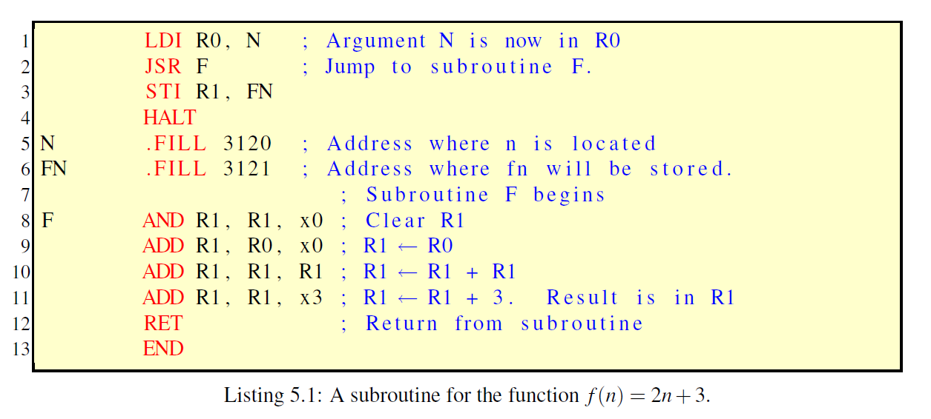
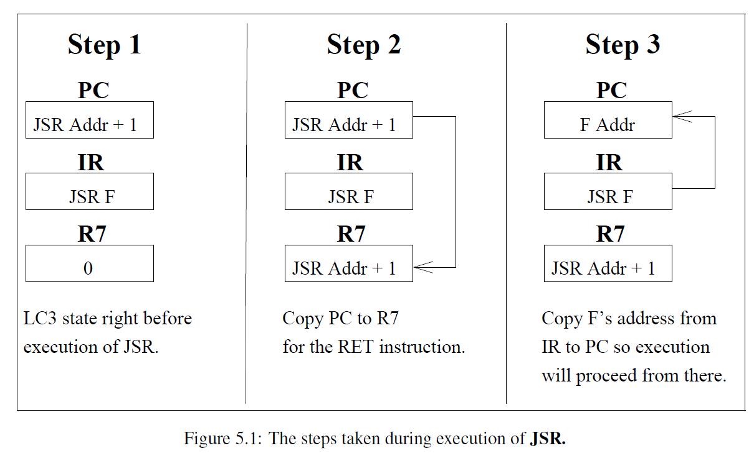

Saving and restoring registers
Make sure that at the beginning of your subroutines you save all registers that will be destroyed in the course of the subroutine. Before returning to the calling program, restore saved registers. As an example, listing 5.2 shows how to save and restore registers R5 and R6 in a subroutine.

Program Structure
The general structure of the assembly program for this problem can be seen in listing 5.3.
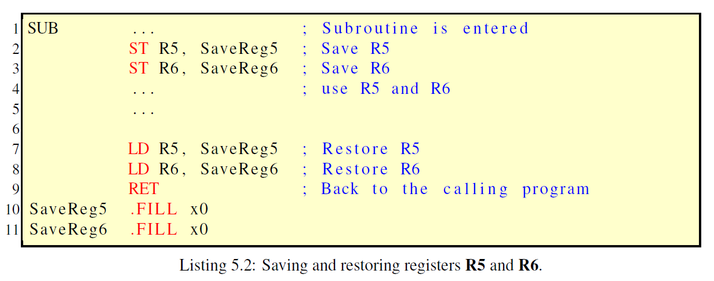
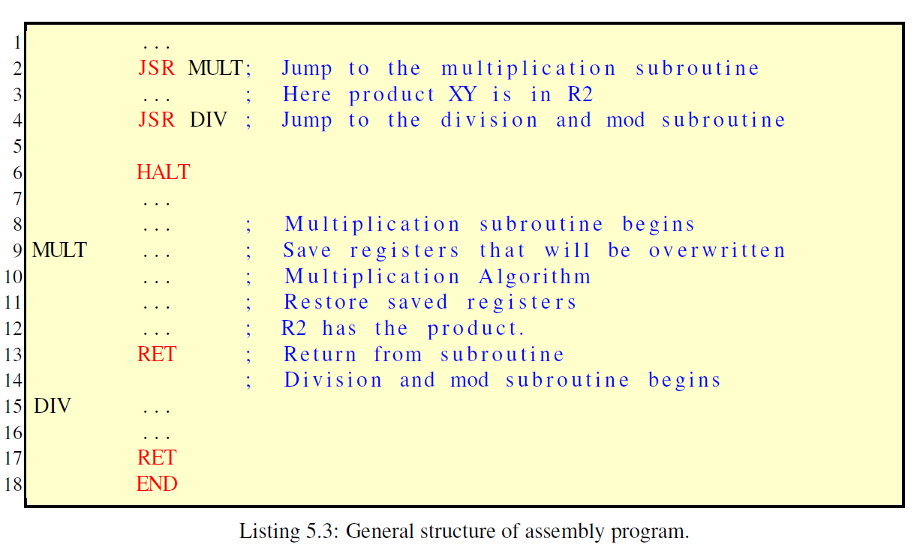

Multiplication
Multiplication is achieved via addition:
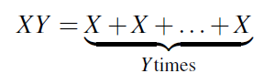
Listing 5.4 shows the pseudo-code for the multiplication algorithm. Parameters X and
Y are passed to the multiplication subroutine MULT via registers R0 and R1. The result is in R2.
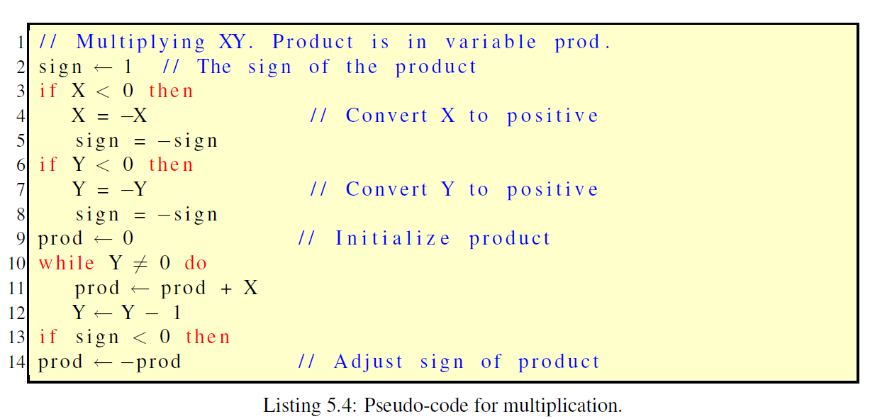

Division and Modulus
Integer division X/Y and modulus X (mod Y) satisfy this formula:
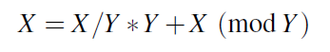
Where X/Y is the quotient and X (mod Y) is the remainder. For example, if X = 41 and Y = 7, the equation becomes
41 = 5*7+6
Subroutine DIV will compute both the quotient and remainder.
- Parameter X is passed to DIV through R0 and Y through R1. For simplicity division and modulus are defined only for X _ 0 and Y > 0.
- Subroutine DIV should check if these conditions are satisfied.
  - If, not it should return with R2 = 0, indicating that the results are not valid.
  - If they are satisfied, R2 = 1, to indicate that the results are valid. Overflow conditions need not be checked at this time. Figure 5.2 summarizes the input arguments and results that should be returned.
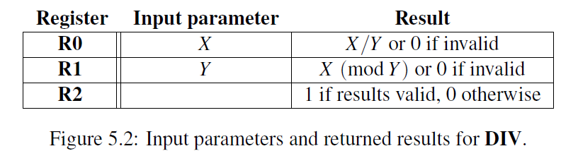
Listing 5.5 shows the pseudo-code for the algorithm that performs integer division and modulus functions. The quotient is computed by successively subtracting Y from X. The leftover quantity is the remainder.
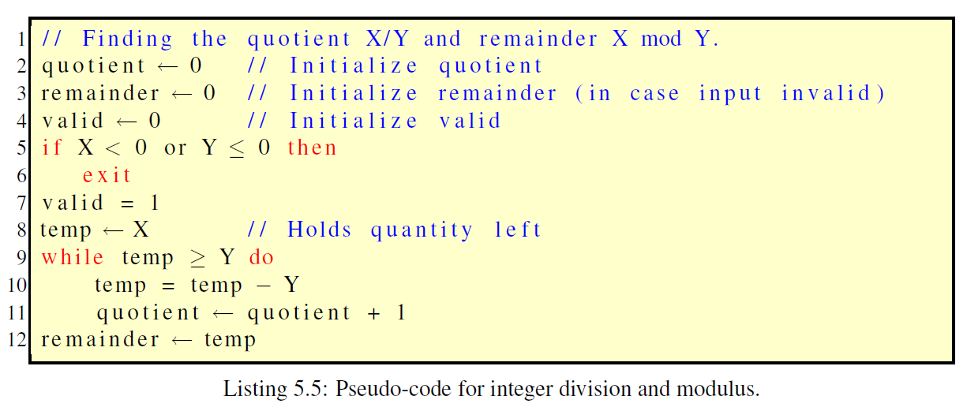

Tasks:
- Create a program in LC-3 based on the given problem statement, input, output and program information. Provide screen captures of code (in Editor), program running successfully (in Simulator).
**Note: You should first write the MULT subroutine, thoroughly test it, and then proceed to implement the DIV subroutine. Thoroughly test DIV. Finally, test the program as a whole for various inputs.

- First, see Listing 5.1 to begin the program by setting up the subroutines using labels for variable X, Y, XY, Quotient and Remainder.
**Note that the example function is different from the required function in the problem statement.
- Second, see Listing 5.2 to set up registers for saving and restoring.
- Third, program the instructions and conditions for multiplication. See Listing 5.4 for pseudo-code. Use 2s’ complement to represent sign-values. Use labels for subroutines.
- See Listing 5.3 for overall program structure using subroutines.
- Test the Multiplication Program.
- Fourth, program the instructions and conditions for division. See Listing 5.5 for pseudocode.
- See Listing 5.3 for overall program structure using subroutines.
- Test the Division program.
- Test the implementation of both Multiplication and Division functionality in the program.

- Test the program: For each of the (X,Y) pairs (10,7), (29,55), (11,−12), (14,0). Provide screen captures that show the contents of locations 3100 through 3104.
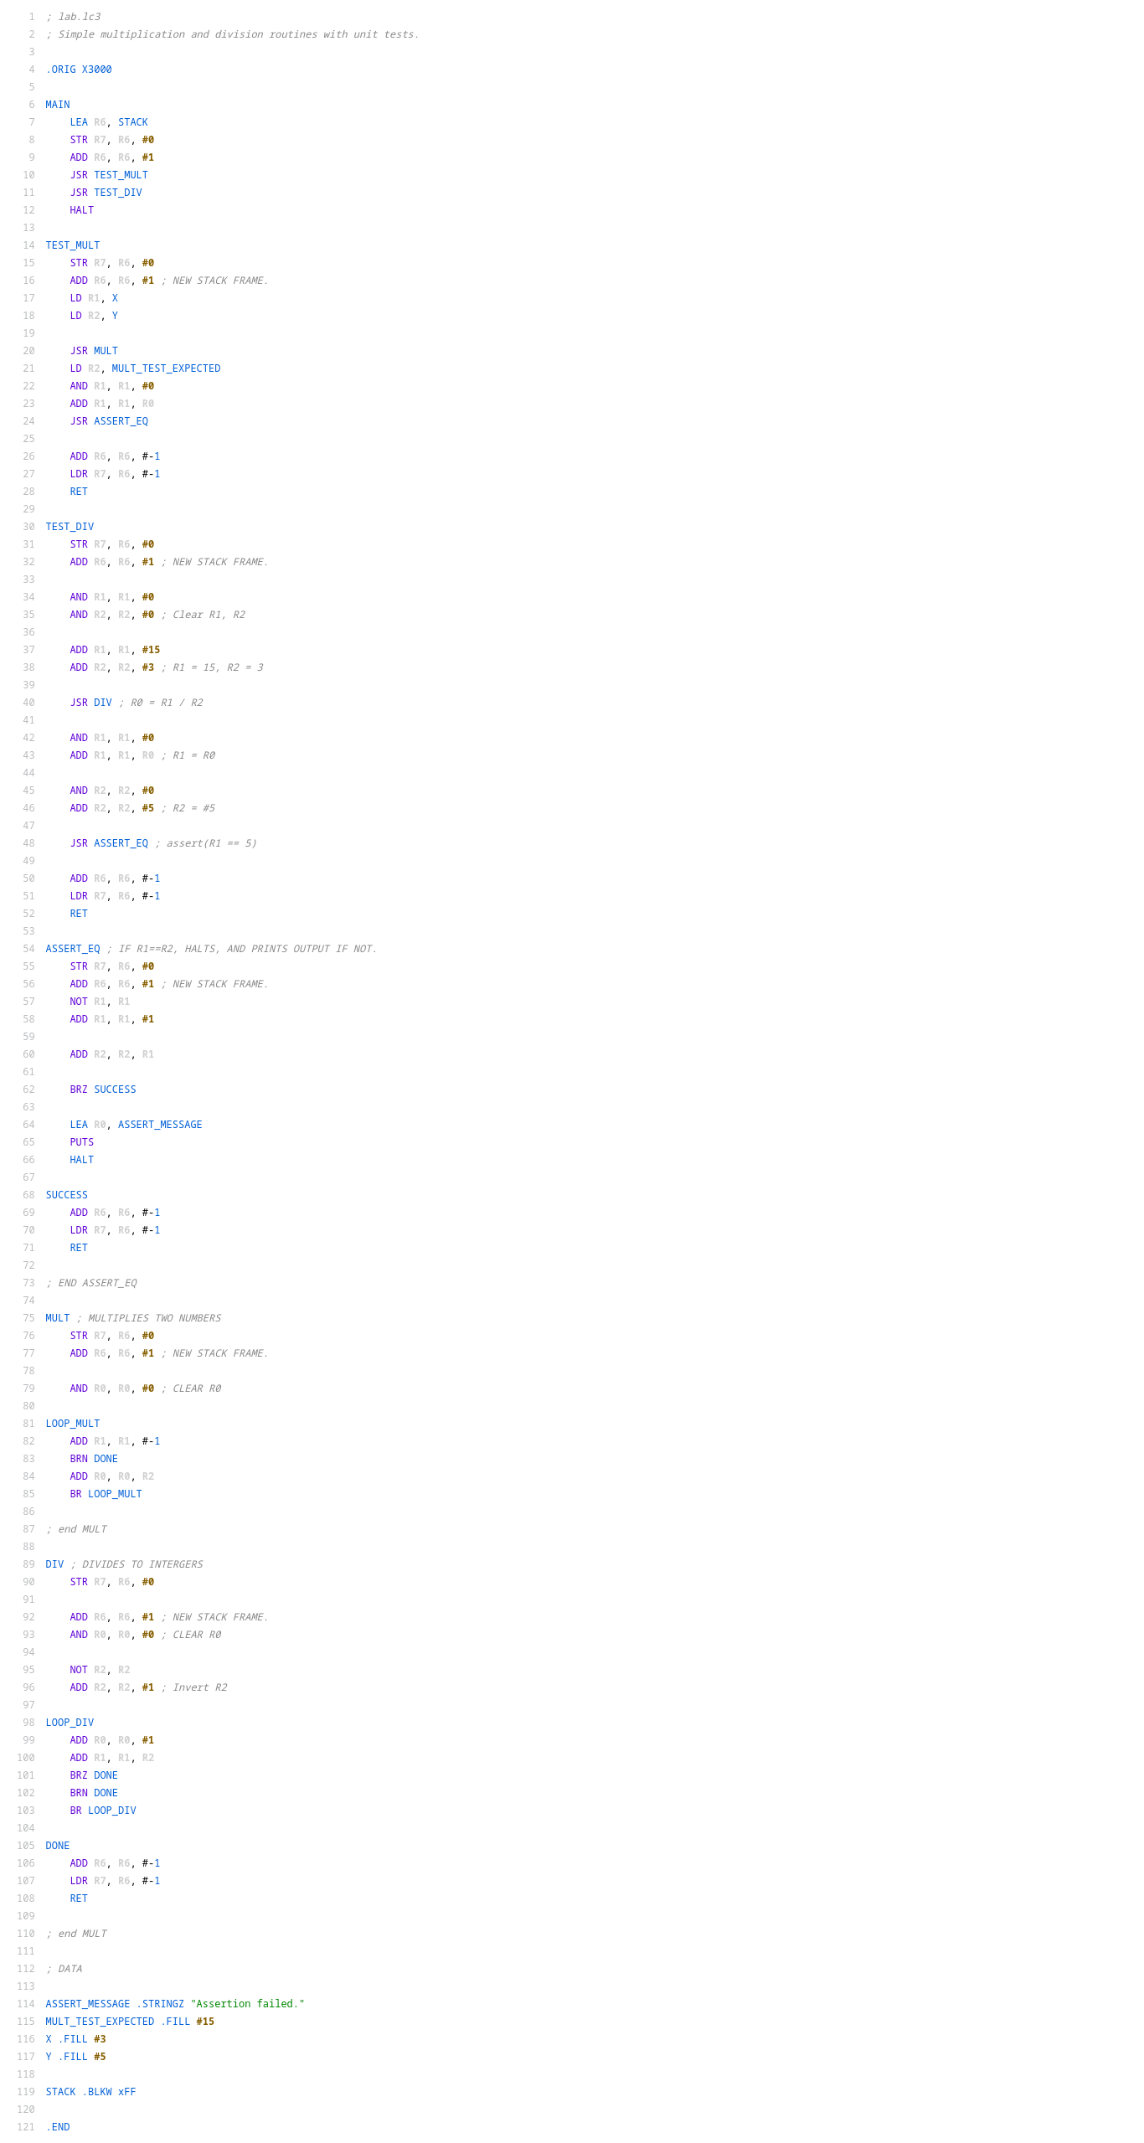
- Answer the following questions:

- What key points did you learn from completing this lab?
I learned about subroutines and keeping track of the stack.
- What were the challenges that you come across when completing this lab?
When I would jump multiple times, R6 would be overridden, so I had to save it to the stack.
- How can you apply subroutines in future LC-3 programming exercises or project?

I can use it break down programs into smaller more manageable chunks, and to organize my projects.

